
March 2026

Pastor’s Corner
Dearest Friends,
This month has held more than one kind of weather. There has been the kind outside — sharp swings, gray skies, sudden warmth that feels almost fragile — and there has been the kind that does not show up on a forecast: the quiet weight of hospital rooms and the sacred ache of walking with families through transition. Some of those stories are not mine to tell, but they are present. They sit in my heart when I stand at the altar. They echo when I pray. There is honor in walking with people in these moments. There is also heartache. Ministry is rarely one or the other. It is both.
At the same time, a different kind of energy has been moving through this season — the kind that comes when a congregation says, “We’re ready to think more deeply about how we worship.” Planning Maundy Thursday and the upcoming stained glass anniversary has not felt like adding something new for novelty’s sake. It has felt like listening — listening to our history, listening to your hopes, listening to the Spirit nudging us toward thoughtful, participatory worship.
There is something deeply grounding about walking through Holy Week again — palms, table, cross, and empty tomb. These rhythms are ancient. They have carried Christians for centuries. They do not need reinvention. And yet, every generation is asked to step inside them again — not as observers of tradition, but as participants in a living story.
That is the call I feel here: to honor what has shaped this congregation for decades, to cherish the stained glass that has filtered light over countless prayers, to stand in hospital rooms and hold hands, and also to ask, gently, “How might we enter the story more fully now?”
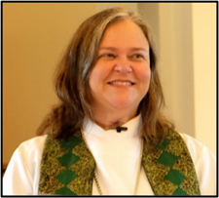
This work is not flashy. It is not always easy. It is not “happy-happy-joy-joy.” It is real. It holds grief and anticipation in the same breath. I am grateful to serve a congregation that wants depth, grateful to walk beside families in their most tender hours, and grateful to plan worship that asks something of us — and gives something back.
Holy Week will ask us to slow down, to feel the tension, to sit in silence, to celebrate, and to hope. We will walk it together — not because it is easy, but because it is true. Thank you for trusting me to walk it with you.
Peace,
Pastor Bunny

Youth News:
Reminder! We meet at 9 AM every Sunday in the large classroom downstairs!
All ages welcome!!!
All are welcome, visitors too!!
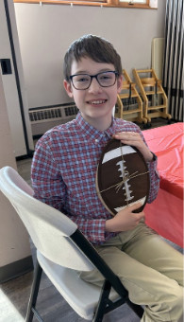
Chili Cook-Off
Thank you to everyone who participated in the 2026 Chili Cookoff and Souper Bowl! We were able to collect so many good items to be donated to the Northwest Neighborhood Food Bank! Not to mention such good chili and great fellowship, too!

Winner of the 2026 OSLC
Chili Cookoff/Soup-er Bowl!
Korver Sindelar!
I need a little help please.
As many know, in addition to my job here at OSLC, I also work as an RN at St. Luke’s. This requires me to work many weekends and unfortunately this year, I have to work on Sunday, March 29th which also happens to be Palm Sunday. If you have been around for a little while, you know Our Savior’s favorite way to celebrate Palm Sunday is with PIE – a.k.a “Pies for Palms.” This is a youth fundraiser that is widely enjoyed each year, and I’d hate to see it go just because I cannot be here. With all that being said, I am looking for a few volunteers to help it continue! The work required is pretty easy and will be all laid out for you. I’d love 3-4 volunteers to help – please reach out to me if you are able to assist! I’m happy to answer any questions you may have! Thank you so much in advance!

Photo from Confirmation Class 2.18.26 - Students were asked to observe how people “lived their faith” during the Lenten worship service.
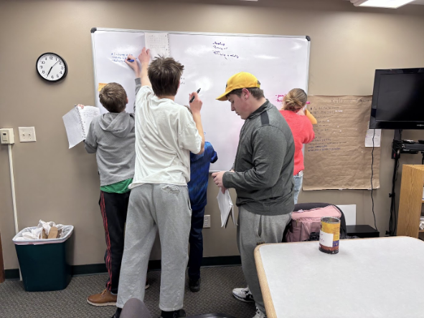

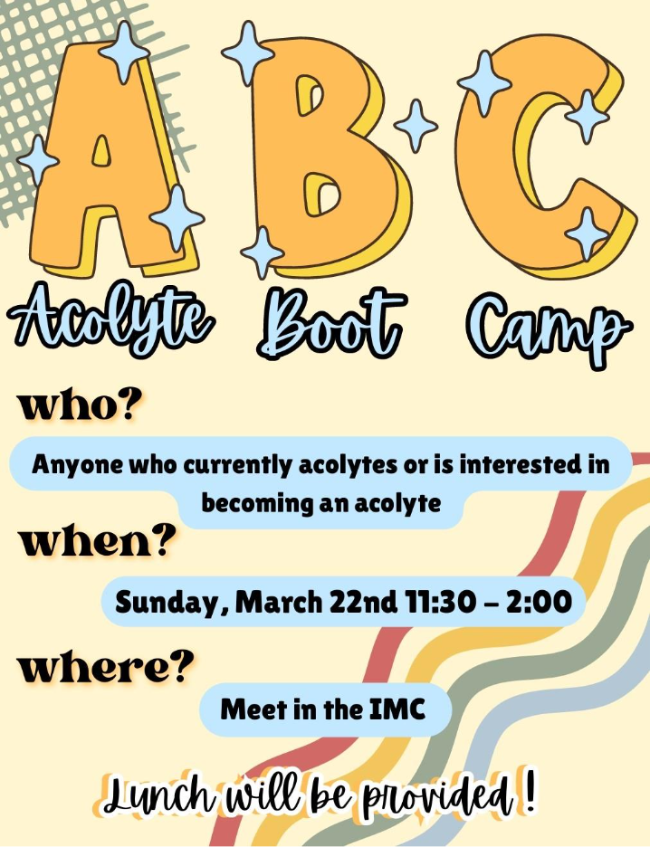
SPECIAL MEETING ANNOUNCEMENT
Your Church Council has requested that a Special Meeting be held on March 15, 2026 immediately after the Sunday Service. A motion was approved by the Council to ask the congregation to consider a motion to hire Nesper Sign Company to construct a digital sign for Our Savior’s. This motion and the specific details of the quote from Nesper, concrete work and all costs will be shared at the meeting. Time will be given for discussion and questions prior to taking a ballot vote on the motion. Please save the date and plan to attend church on March 15th for this important special meeting.
Thank you – Sue Clapp
Lent Bingo!!

It’s hard to believe but Lent is coming and we have a very fun way to celebrate this year! LENT BINGO! Bingo cards will be available starting Sunday, February 15th. Each BINGO will be awarded a prize – see Hannah once you get a BINGO to claim your prize! You can get as many as possible throughout the Lenten season. The last day to claim a BINGO is Sunday, April 5th (Easter Sunday). The goal is to have fun and encourage participation from all ages! Please reach out to Hannah with any questions!

Phil & Andy’s Pantry
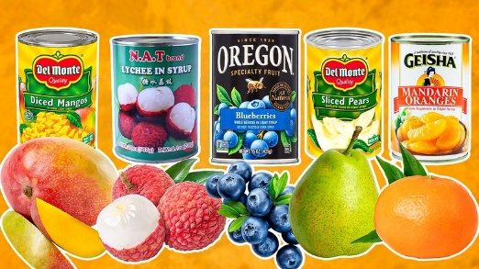
For March and April, we are requesting donations of simple dessert mixes and canned fruit.
Please consider donating cans of fruit such as peaches, pears, pineapple, fruit cocktail and simple dessert items like jello and pudding. Those in need will appreciate anything we are able to share. Thank you from your Stewardship Ministry Team.

Walking the Week That Changes Everything
Holy Week 2026 | March 29 – April 5
Holy Week is not just a series of services. It is one unfolding story — and it only makes sense if we walk it together. We begin on Palm Sunday, March 29, waving branches and singing “Hosanna.” It is a day of movement and sound, of hope and expectation. The crowd believes something powerful is about to happen. And it is — just not in the way they imagine.
From there, we move toward the table.
This year, we are placing special weight and intention on Maundy Thursday, April 2, with a dinner church service called A Living Last Supper. Instead of gathering in the sanctuary, we will meet in the fellowship hall and sit at tables for a simple meal — closer to how that night actually unfolded. During the meal, members of our congregation will rise and speak as the disciples — not as actors, but as witnesses. We will hear confusion, hope, ambition, tenderness, and betrayal. And in the middle of the meal, just as the Gospel tells it, we will share Holy Communion while we are still eating.
The service will be quieter than usual. There is no dessert. There is no closing blessing. We will leave in silence and carry the weight of the night into Good Friday.
Last year, much of our creative and emotional energy centered on Good Friday. This year, we are intentionally focusing our time and care on Maundy Thursday. Concentrating our attention in one place allows us to engage more deeply rather than spreading ourselves thin.
Good Friday, April 3, remains solemn and honest — a day to stand at the foot of the cross and tell the truth about suffering, grief, and love that does not turn away.
And then comes Easter Sunday, April 5. Easter is not a reset button. It is resurrection breaking into a world that has walked through betrayal, silence, and loss. We will gather to proclaim that death does not have the final word — that hope rises even when we least expect it.
Holy Week is one story told over several days. Each part deepens the next.
I invite you to walk the whole week — from palms to table, from cross to empty tomb. Come ready not just to observe the story, but to sit inside it.
Help Bring It to Life
Both Maundy Thursday and our Easter celebrations depend on many hands — in preparation, hospitality, music, setup, and care. Clear and simple volunteer opportunities will be available in the coming weeks.
If you’ve been hoping for thoughtful worship, this is one way to help shape it. I invite you to sign up and be part of bringing Holy Week to life.
There is room at the table — and room to serve.

Wrapping the Synod in Peace
As our Southeastern Iowa Synod prepares for the 2026 Synod Assembly, congregations across the region are being invited to help embody this year’s theme: “Peace Be With You.”
One of the ways that peace will be made visible is through handmade prayer shawls, lap quilts, and small quilts — gifts of warmth and care created by hands throughout the synod. These pieces will surround the Assembly as tangible reminders of Christ’s presence and the prayers of God’s people.
Each shawl or quilt may become a keepsake for a voting member or participant, or it may be left behind and later shared with someone in need — extending peace beyond the Assembly itself.
If you knit, crochet, or sew — or if you’ve ever thought about beginning — this is a beautiful opportunity to participate in something larger than ourselves.
Suggested sizes:
• Prayer shawls: approximately 18–24 inches wide and 60–72 inches long
• Lap quilts: approximately 36 x 45 inches (wheelchair-sized)
If you are able to make one or two items, please let Pastor Bunny know. The synod office needs an estimated count in advance, so it is important that we know what is being created.
Please have finished items brought to church by May 10 so they can be gathered and delivered in time for the Assembly.
This is a simple act — thread, yarn, time, prayer — but together it becomes a visible sign of community and care. Let’s help wrap our synod in peace!

Pies for Palms – March 29th!
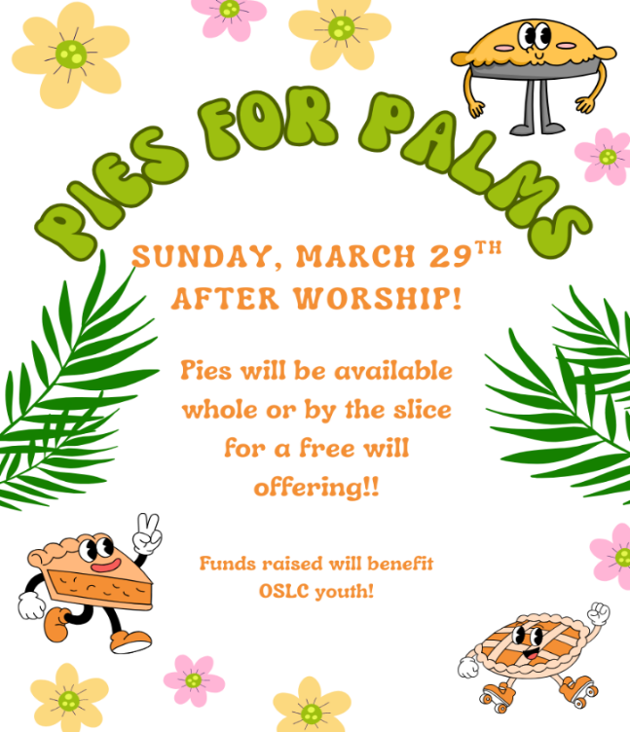
Join us right after 10:00 worship on Palm Sunday, March 29th for our annual youth fundraiser; Pies for Palms!! Pies will be available by the slice for a free will offering. There will also be some whole pies available for purchase as well – a great deal if you’re hosting for Easter or just want a yummy dessert! If you are interested in donating a pie, there will be a sign-up sheet on the bulletin board! Donated pies can be homemade or store bought!

St. Patrick, the Lutheran...?
While St. Patrick was not making Lefse or Lutefisk as far as we know, Lutherans recognize him as more than just an Irish guy for whom we celebrate with green beer and parades. St. Patrick brought the Gospel to Ireland and used the 3-leaf clover as a sign of the Holy Trinity! When you put on your favorite green shirt this St. Patrick’s Day and put your corned beef in the crockpot, remember St. Patrick as the theologian whose focus was grace. Our Lutheran Service Book hymn #604 “I Bind Myself Unto Thee” is even a version of the hymn “St. Patrick’s Breastplate!”


Annual Easter Breakfast!!
The OSLC famous Easter Breakfast will be Sunday, April 5th from 8:00 – 9:30 AM. In order to make a great breakfast, we need the ingredients to do so! There will be a donation sign up on the bulletin board. Please have all food donations at church by 9:00 on Saturday, April 4th! We also need helping hands to set up, cook, serve, and tear down! There will also be volunteer sign-ups on the bulletin board – these include different shifts and generally what tasks will be involved. Don’t worry! We will make sure you get to sit down and enjoy a famous breakfast, too! Contact Hannah with any questions!

What do you think?
The Fellowship Ministry Team is considering a change to the 2026 Christmas party. OSLC has held an evening Christmas party for many years. The team is kicking around the idea of changing to a Christmas brunch following worship service. What do you think? Watch for the bulletin insert during March. Tell us which you prefer----Christmas brunch following worship service or Christmas party on a Sunday evening.

40 Years of Light: Celebrating Our Stained Glass Windows
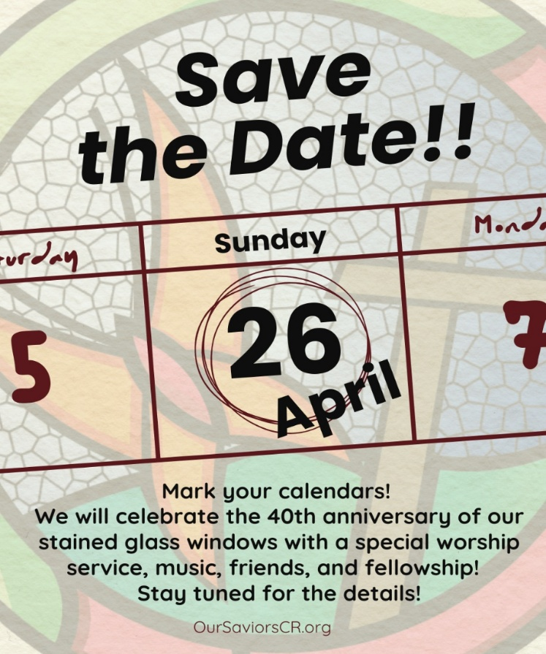
This spring we will celebrate the 40th anniversary of the dedication of our stained-glass windows — a milestone that invites both gratitude and joy.
For four decades, these windows have shaped how we experience worship. They tell the story of Scripture in color and light. They frame our prayers. They catch the morning sun and remind us that faith is not only heard — it is seen.
On our anniversary Sunday, we will hold a special lessons-and-carols style service centered on the windows themselves. Rather than a traditional sermon, the windows will preach. Our youth will introduce each window, and detailed descriptions will be printed in the bulletin so that we can reflect more deeply on the theology and artistry woven into the glass.
An assistant to the bishop will join us to preside at Holy Communion, and the music will echo themes from the original dedication service — honoring our history while celebrating the present.
Following worship, we will gather for a reception designed to welcome former members, previous pastors and staff, donors, and friends of the congregation. This is not simply an anniversary of a building feature; it is a celebration of the faithfulness of a community that has gathered beneath these windows for 40 years.
The light that shines through the glass is the same light that has carried this congregation forward — through change, growth, challenge, and hope.
We hope you will join us for this meaningful and joyful celebration as we give thanks for where we have been and look ahead to where God is leading us next.
Volunteer opportunities for hospitality, decorations, setup, and reception support will be available soon. If you would like to help bring this celebration to life, we would love your participation.

________________________________________________________________________________________________________________________________________________
Serving Our Congregation

Bunny Dillard – Head Pastor
Sue Clapp – Congregation President
David Sampson – Treasurer
Therese Plummer – Office Manager
Hannah Plummer – Children & Youth Ministries Director
Forrest Green – Music Director
Terri Hodge – Bell Choir Director

__________________________________________________________________________________________________________________________________________________

Readers

March 1 – Therese Plummer

March 8 – Joann Kohl

March 15 – Eric Robinson

March 22 – Therese Plummer

March 29 – Lori Hayes

April 5 – Nancy Trout

April 12 – Ann Larson

April 19 – Sue Clapp

April 26 – Suzanne Schmitt

**Readers can pick up their reading in the “Reader” mailbox located between the offices in the back hallway.

Acolytes

March 1 – Eric Strottman

March 8 – Evy Fiester

March 15 – Parker Zeien

March 22 – Mason Schmitt

March 29 – Eric Strottman

April 5 – Evy Fiester

April 12 – Eric Strottman

April 19 – Mason Schmitt

April 26 – Parker Zeien

Assisting Ministers

March 1 – Sue Clapp

March 8 – Natalie Fiester

March 15 – Sue Clapp

March 22 – Hannah Plummer

March 29 – Nancy Greer

April 5 – Sue Clapp

April 12 – Natalie Fiester

April 19 – Hannah Plummer

April 26 – Nancy Greer
Ushers

March 1 – Strottman Family

March 8 – D. Sampson, M. Houg, T. Zuber

March 15 – Mark & Suzanne Schmitt, Ann Larson, Beth Anderson

March 22 – Fiester Family

March 29 – Sue Clapp, Al Johnson,

Bob Sindelar

April 5 – D. Sampson, M. Houg, T. Zuber

April 12 – Strottman Family

April 19 – Mark & Suzanne Schmitt, Ann Larson, Beth Anderson

April 26 – Fiester Family

Prayer for Pastor

March 1 – Lori Hayes

March 8 – JoAnn Kohl

March 15 – Arnold Strottman

March 22 – Karen Janney

March 29 – Natalie Fiester

April 5 – Laurie Strottman

April 12 – Ann Larson

April 19 – Diana Emig

April 26 – Therese Plummer

Greeters

March 1 - Marv Gerjets

March 8 – Sue Clapp

March 15 – Al Johnson

March 22 – Therese Plummer

March 29 – Ardy Erickson

April 5 – Marv Gerjets

April 12 – Bob Sindelar

April 19 – Sue Clapp

April 26 – Suzanne Schmitt

Children’s Sermon

March 1 – Beth Anderson

March 8 – Hannah Plummer

March 15 – Pastor Bunny

March 22 – Hannah Plummer

March 29 – Beth Anderson

April 5 – Hannah Plummer

April 12 – Pastor Bunny

April 19 – Hannah Plummer

April 26 – Beth Anderson

Sunday School Teacher

March 1 – Natalie Fiester

March 8 – Natalie Fiester

March 15 – Hannah Plummer

March 22 – Hannah Plummer

March 29 – Natalie Fiester

April 5 – No Sunday School

April 12 – Natalie Fiester

April 19 – Hannah Plummer

April 26 – Natalie Fiester

__________________________________________________________________________________________________________________________________________________
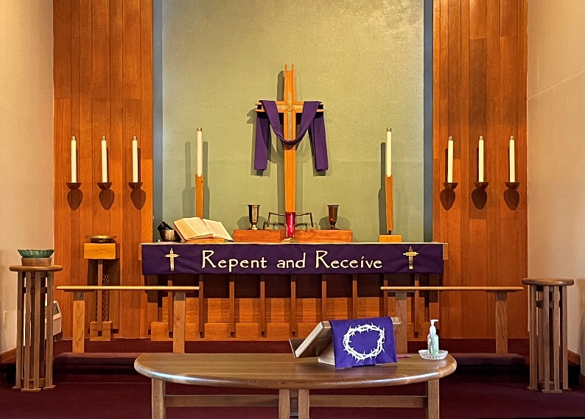
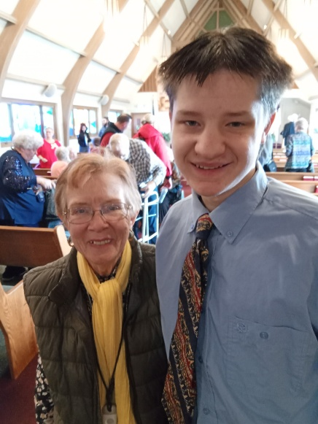
Submitted Photos
By
Rick
Rogness

By
Laurene
Case

